Asia-China-Mirror-Sotheby's-2011

# Sotheby's, NY

04 septembre 2011

## [Chinese Antique Bronze Mirrors @ Sotheby's, NY](http://www.alaintruong.com/archives/2011/09/04/21940789.html)

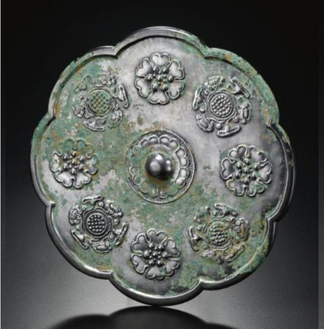

A Large Silvered Bronze Lobed Mirror. Tang Dynasty. Photo Sotheby's

well cast, of eight-lobed form, the central hemispherical knop enclosed by eight petals within a circular dog-tooth frame, the decorative field with four luscious open flowerheads alternating with four clusters of lotus flowers, all cast in shallow relief with raised outlines, the bright silvery patina with areas of light green encrustation. Diameter 10 3/8 in., 26.4 cm. Estimate  15,000-20,000 USD

Property Of The Sano Art Museum, Mishima City,Shizuoka

NOTE: A popular mirror type during the Tang period, mirrors of this type are often of large size and bright silvery patina. Compare an example from the Carter Collection, now in the Cleveland Museum, illustrated in Chou Ju-hsi, Circles of Reflection. The Carter Collection of Chinese Bronze Mirrors, Cleveland, 2000, pp. 67-68, cat. no. 58.

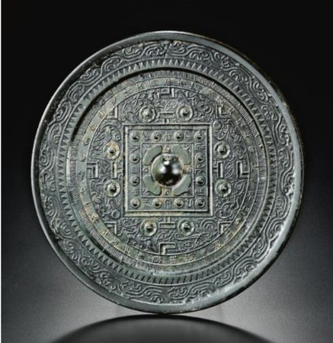

A Large Bronze 'TLV' Mirror. Han Dynasty. Photo Sotheby's

the central hemispherical boss framed by a concave square frame set with twelve small bosses alternating with characters, the broad rim cast with branching scrolls enclosing a narrow 'dog tooth' border, the main field cast with four 'T', 'L' and 'V' motifs arranged between eight small bosses, on a ground of animals and winged immortals cast in linear relief, encircled by a narrow frieze bearing an inscription; Diameter 8 3/8 in., 23.2 cm. Estimate  12,000-15,000 USD

Property Of The Sano Art Museum, Mishima City,Shizuoka

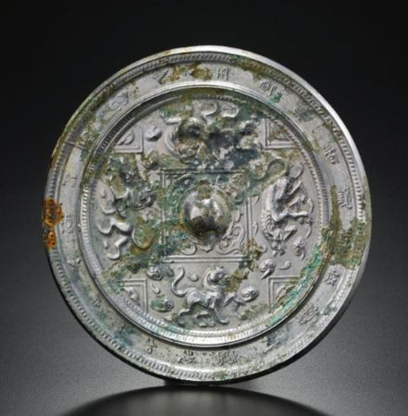

 A Silvered Bronze Mirror. Sui-Early Tang Dynasty. Photo Sotheby's

the pierced hemispherical boss surrounded by trefoil motifs within a grooved square encircled by four fabulous lion-like beasts galloping amidst wisps of clouds and flames, separated by four V-shaped motifs arranged at the four corners of the decorative field, all within a raised dog-tooth border surrounded by a long circular inscription enclosed by a raised dog-tooth pattern, the silvery patina with patches of malachite encrustation. Diameter 6 1/4 in., 15.9 cm. Estimate  12,000-15,000 USD

Property Of The Sano Art Museum, Mishima City,Shizuoka

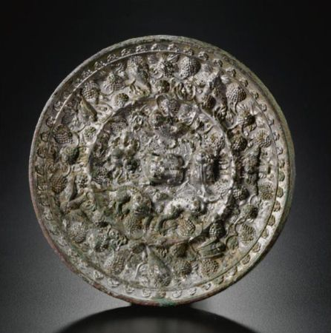

A Silvered Bronze 'Lion And Grapevine' Mirror. Tang Dynasty. Photo Sotheby's

cast within a high wedge-shaped rim with a frieze of numerous birds and insects among the meandering stems of a fruiting vine, divided by a ridge bordered with a fine raised double-line from the central field of five lions among scrolling vine stems around the central crouching lion forming thel boss, with a bright silvery patina with areas of encrustation predominantly on the edges and reverse. Diameter 5 3/4 in., 14.6 cm. Estimate  10,000-15,000 USD

Property Of The Sano Art Museum, Mishima City,Shizuoka

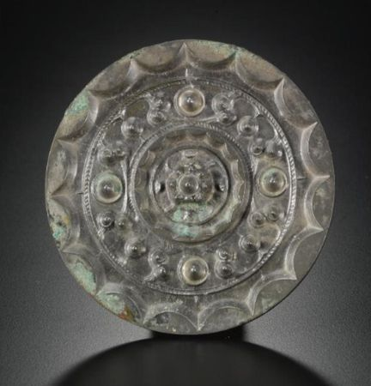

A Bronze 'Star Cluster' Mirror. Western Han Dynasty. Photo Sotheby's

the high nippled central boss encircled by a high ring with an inverted scalloped rim, surrounded by a band of high bosses arranged in clusters of five and interspersed with four high bosses, the raised rim formed of sixteen arcs, the patina a smooth dark gray tone with some green encrustation; Diameter 4 3/8 in., 11.1 cm. Estimate  8,000-12,000 USD

Property Of The Sano Art Museum, Mishima City,Shizuoka

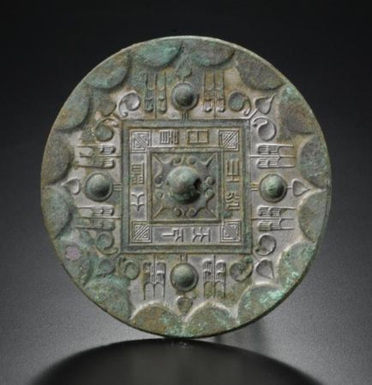

A Bronze 'Cao Ye' Mirror. Western Han Dynasty. Photo Sotheby's

the hemispherical boss enclosed by four trefoils extending to the corners of a square border cast with eight characters reading jian ri zhi guang, tianxia da ming (by the light of the sun the world is illuminated), in turn surrounded by a ring with four bosses alternating with stylized tree motifs and trefoils with concave leaves, all set within a raised border of semi-circles around the rim, the silvery patina with patches of encrustation. Diameter 5 1/2 in., 14 cm. Estimate 8,000-12,000 USD

 Property Of The Sano Art Museum, Mishima City,Shizuoka

NOTE: For a related example of this mirror type discovered in the tomb of Dou Wan, consort of Liu Sheng, Prince Jing of the Western Han kingdom of Zhongshan, compare Mancheng Han mu fajue baogao, Beijing, 1980, vol. 2, pl. 181: 1.

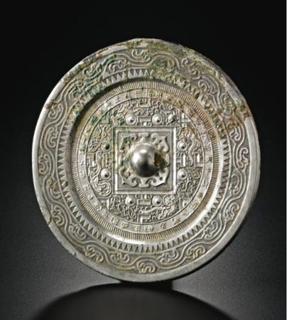

A Small Bronze 'TLV' Mirror. Western Han Dynasty. Photo Sotheby's

the pierced hemispherical knop enclosed by four barbed ruyi heads and a grooved square issuing four 'T' motifs each flanked by a two raised bosses, the remainder of the field cast with four 'L' and 'V' motifs interspersed with the four directional animals and winged immortals in fine linear relief, all enclosed by an inscription band, the wide flat rim cast with a band of stylized scrolls and 'dog tooth' pattern, the bronze a steely gray tone, some malachite and cuprite encrustation; Diameter 5 1/2 in., 14 cm. Estimate 8,000-12,000 USD

Property Of The Sano Art Museum, Mishima City,Shizuoka

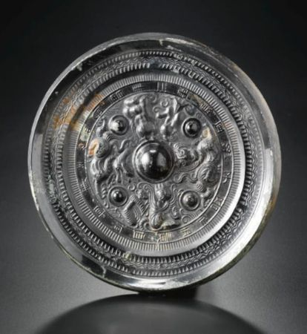

A Bronze 'Shen Shou' Bronze Mirror. Han Dynasty. Photo Sotheby's

with a lustrous black patina, the main field cast with a pair of ferocious beasts and the figures of Dongwanggong and Xiwangmu, both wearing their respective headdresses and flanked by attendants and separated by four bosses, all encircled by an inscription band, the inward-sloping rim with bands of striations, dog-tooth and wavy-line borders. Diameter 5 7/8 in., 15 cm. Estimate 8,000-12,000 USD

Property Of The Sano Art Museum, Mishima City,Shizuoka

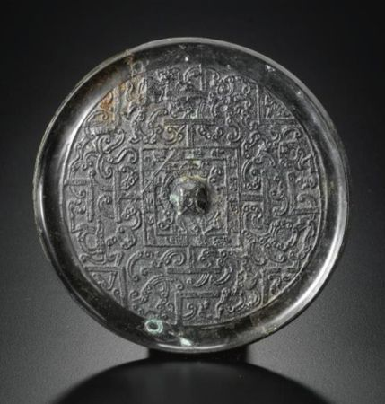

A Rare Early Bronze 'TLV' Mirror. Western Han Dynasty. Photo Sotheby's

thinly cast, the narrow loop handle enclosed by two stylized dragons and an inscription within a square from which four 'T' motifs radiate, the central field filled with dissolved dragon scrolls between evenly spaced and finely grooved 'T', 'L' and 'V' motifs, patinated to a smooth black color; Diameter 4 5/8 in., 11.7 cm. Estimate 6,000-8,000 USD

Property Of The Sano Art Museum, Mishima City,Shizuoka

NOTE: One of the earliest versions of theTLV-mirror type, related examples have been excavated from tombs of the early to mid-Western Han dynasty. The most prominent example was discovered in the tomb of Dou Wan, consort of Liu Sheng, Prince Jing of the Western Han kingdom of Zhongshan, compare Mancheng Han mu fajue baogao, Beijing, 1980, vol. 2, pl. 181: 2.

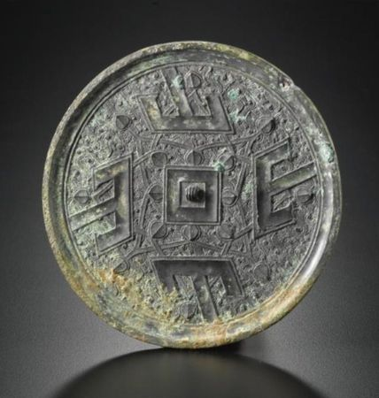

A Rare Bronze 'Shan' Mirror. Eastern Zhou Dynasty, Warring States Period. Photo Sotheby's

the small fluted loop framed by a concave square border from which radiate four heart-shaped leaves, each supporting short straight stems terminating in further leaves, divided by four large grooved 'T' motifs converging from the raised rim, all on a fine ground of hooks, wings and feathers, with a steely patina and patches of dark green encrustation; Diameter 5 1/16 in., 13 cm. Estimate 5,000-7,000 USD

Property Of The Sano Art Museum, Mishima City,Shizuoka

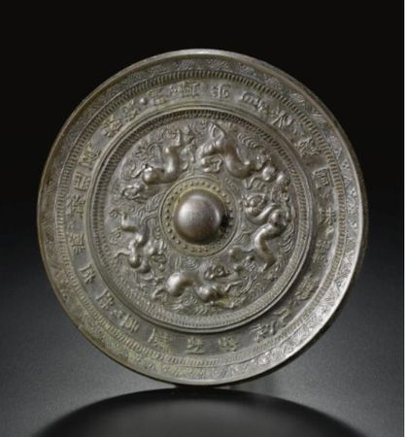

A 'Rui Shou' Bronze Mirror. Early Tang Dynasty. Photo Sotheby's

heavily cast with five ferocious beasts galloping around the hemispherical central boss amidst wisps of clouds and flames and on cresting waves, all enclosed by an inscription band near the inward-sloping rim, the bronze patinated to a dark brown tone. Diameter 5 3/4 in., 14.6 cm. Estimate 5,000-7,000 USD

Property Of The Sano Art Museum, Mishima City,Shizuoka

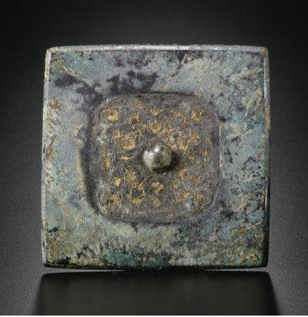

A Rare Bronze 'Pingtuo' Mirror. Tang Dynasty. Photo Sotheby's

of square shape with a wide undecorated rim enclosing the main decorative field embellished with a design of delicate gilt-silver sheet flowers forming a meandering scroll and laid on a lacquer ground around the small hemispherical boss at the center. Width 4 in., 10.2 cm.. Estimate 5,000-7,000 USD

Property Of The Sano Art Museum, Mishima City,Shizuoka

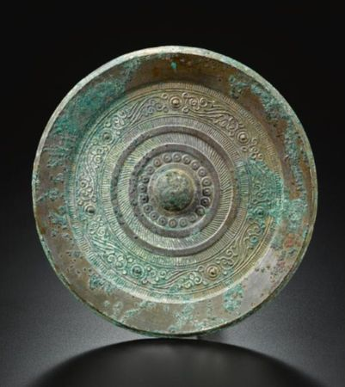

A Bronze Mirror. Han Dynasty. Photo Sotheby's

the decoration principally cast in concentric bands of striations and stylized scrolls interspersed with small bosses around the large central hemispherical boss, the wide inward-sloping rim undecorated, the silvery patina with some malachite and cuprite encrustation; Diameter 7 1/4 in., 18.4 cm. Estimate 3,000-5,000 USD

Property Of The Sano Art Museum, Mishima City,Shizuoka

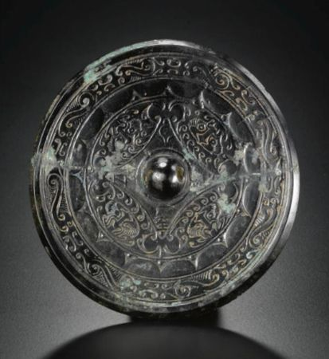

A Small Bronze 'Shou Shou' Mirror. Han Dynasty. Photo Sotheby's

thinly cast in shallow relief around the small hemispherical boss with four radiating trefoil motifs dividing the decorative field into four lens-shaped segments each filled with a stylized taotie mask, all set within a band of inverted linked semi-circles and a band of formalized scrolls near the rim, the dark patina with some greenish encrustation; Diameter 4 1/2 in., 11.5 cm. Estimate 3,000-5,000 USD

Property Of The Sano Art Museum, Mishima City,Shizuoka

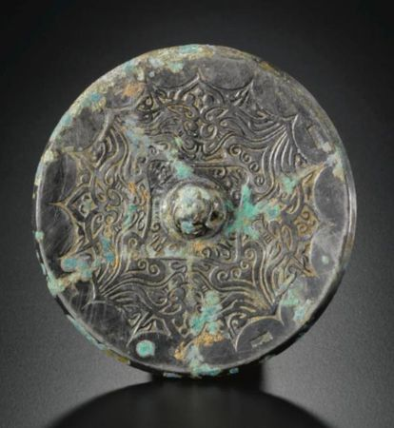

A Bronze 'Phoenix' Mirror. Late Han Dynasty. Photo Sotheby's

thinly cast in shallow relief with four trefoil motifs radiating from a square enclosing the central mountain-shaped boss and separating confronting pairs of phoenix, all enclosed by a scalloped border; Diameter 4 1/8 in., 10.6 cm. Estimate 3,000-5,000 USD

Property Of The Sano Art Museum, Mishima City,Shizuoka

Sotheby's. Fine Chinese Ceramics & Works of Art. New York. 14 september 2011 [www.sothebys.com](http://www.sothebys.com/)

Posté par Alain Truong à 19:44 - [Bronzes de Chine/Chinese Bronzes](http://www.alaintruong.com/archives/bronzes_de_chine_chinese_bronzes/index.html) - [Commentaires [0]](http://www.alaintruong.com/archives/2011/09/04/21940789.html" \l "comments) - Permalien [[#](http://www.alaintruong.com/archives/2011/09/04/21940789.html)]   
Tags : ['lion and grapevine'](http://www.alaintruong.com/tag/'lion and grapevine'), ['Star Cluster'](http://www.alaintruong.com/tag/'Star Cluster'), [bronze mirror](http://www.alaintruong.com/tag/bronze mirror), [Han Dynasty](http://www.alaintruong.com/tag/Han Dynasty), [Sui-Early Tang Dynasty](http://www.alaintruong.com/tag/Sui-Early Tang Dynasty), [Tang dynasty](http://www.alaintruong.com/tag/Tang dynasty), [TLV type](http://www.alaintruong.com/tag/TLV type), [Western Han dynasty](http://www.alaintruong.com/tag/Western Han dynasty)